Prairie Pie
GC infused Whey Eau de vie, Rittenhouse Rye, Apple-Cinnamon Soba Cha Syrup, Neversink, Allspice Dram, Demerara, Egg White
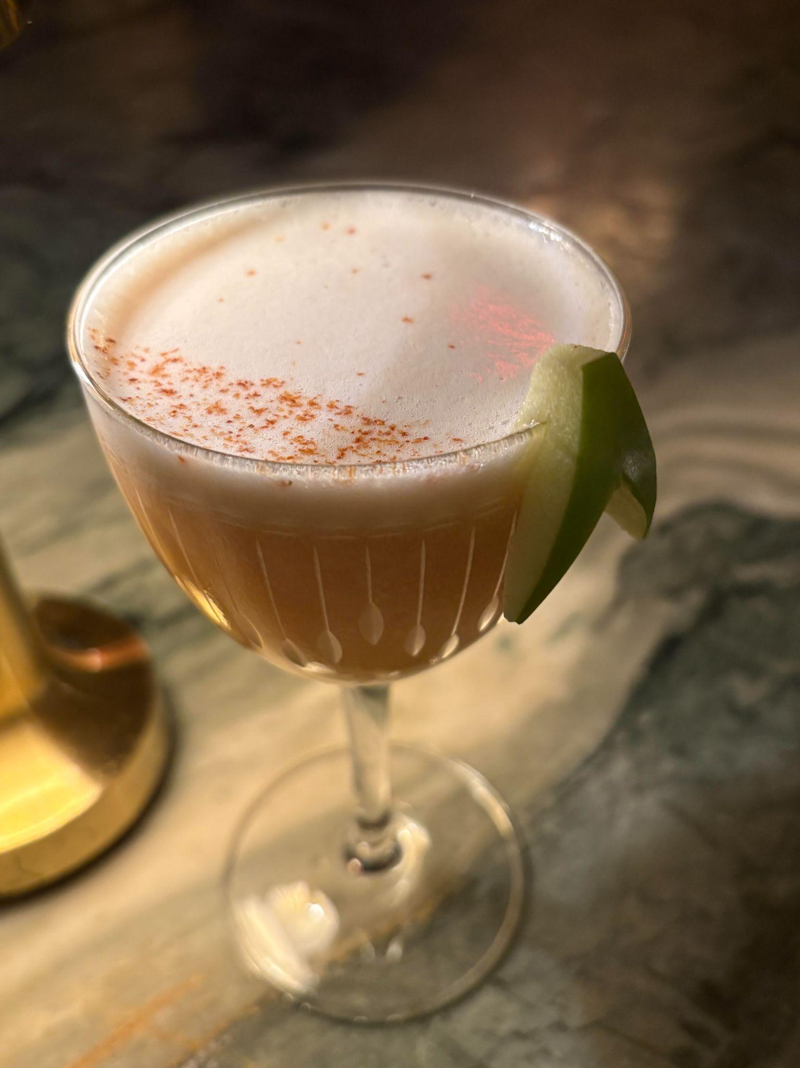
Inspiration: A dessert-inspired riff on an applejack/whiskey sour. The name nods to both the classic flavors of American apple pie and a Canadian staple, “Lost Prairie Pie”, a graham cracker-crusted pie topped with cinnamon and meringue. It also reflects the drink’s two core spirits: a graham-cracker-infused Whey Eau de Vie from Quebec and American Rittenhouse Rye (whose depth rounds out the cocktail’s warm, pastry-like profile). The Apple-Cinnamon Syrup anchors the cocktail, with the rich flavors of cooked-down apples and a subtle toastiness from the roasted buckwheat. Neversink adds a thread of gentle bitterness for balance, while allspice lifts the winter-spice notes that tie the whole drink together.

Presentation: Dry Shaken, served up in a N/N glass.

Garnish: cinnamon dusting over egg white, apple wing garnish.

Ingredients:
Graham Cracker infused Eau de vie de petit lait: A Canadian (Quebec) based spirit made from “whey” that's left over from their cheese factory. Second-generation cheese makers are utilizing leftover curds to produce this eau de vie. The spirit is lactose-free and distilled three times, reduced with water coming from the family's mountains. We steep this spirit in ground-up graham crackers for ~2 hours, and clarify through a coffee filter

Rittenhouse Rye: In 1934, Rittenhouse Square Straight Rye Whisky hit the market and quickly became known as the “Choice Pennsylvania Rye.” A flavor profile that highlights the rye's spice, the corn's subtle sweetness and texture, and a bit of toast from the barley. 100 percent proof allows for a strong flavor foundation that doesn't get lost when mixed.

Apple-Cinnamon Soba Cha Syrup: Peeled apples mixed with cinnamon and sugar, cooked down into a syrup. Blended with Soba Cha tea to give a nutty and toasty flavor.

Neversink: A Pommeau de Normandie-style aperitif made by Neversink Spirits in Elmsford, New York. It's a blend of brandy aged for approximately 1 year before blending with bittersweet cider pressed from heirloom apples. The blend is then aged in neutral French oak barrels for a minimum of 1.5 years. It has notes of red apple, walnut, butterscotch toffee, clove, sage, celery root, ginger, and fresh apple skin.

St. Elizabeth All Spice Dram: From its origins in the tropical hills and valleys of Jamaica, the allspice berry has for generations been prized for its exceptional tastes of clove, cinnamon, and nutmeg, and a pepper note that dazzles the palate. The berry, called “pimento” in Jamaica, gets its modern name from its flavors of clove, cinnamon, nutmeg, and pepper. St. Elizabeth Allspice Dram is a traditional preparation made with smoky Jamaican pot-still rum.

Allergies: Dairy, Apple, Citrus, Egg, Gluten & Soy (graham crackers)

